Sandridge Parish Council

Simon Thwaites Marshalswick Community Centre,
Parish Clerk The Ridgeway, St. Albans,
Herts, AL4 9TU Tel: 01727 831871 Email: clerk@sandridge-pc.gov.uk

10th September 2026 www.sandridge-pc.gov.uk

TO: MEMBERS OF THE SPORTS AND RECREATION GROUNDS COMMITTEE

Councillors: James Lambert (Chair), Carol Chalkley, Mike White, Raihanna Ahmed, Nik Forman, Debbie Chachulski

Public members: Jez Cox, Chris Cooke

Officers: Rebecca Pannese; Project, Amenities and Community Engagement (PACE) Officer,
Simon Thwaites; Parish Clerk

A meeting of the Sports and Recreation Grounds Committee is to be held on Wednesday 16th September 2026 at 7.30pm at Marshalswick Community Centre.

A G E N D A

- Apologies for Absence

- Disclosures of Interest and Dispensations
To receive declarations of interest from Members on items on the agenda and to receive
written requests for dispensations for declarable interests.

- Election of Chair

- Election of Vice Chair

- Review and approve the Terms of Reference for the forthcoming year

- To approve the minutes of the Sports and Recreation Grounds Committee meeting held
on the 18th March 2026

- 2026/27 Capital Works
The budget for 2026/27 is as follows;

- £40,000 Capital works (currently unallocated)
- £6,725 Maintenance and responsive works
- £5,750 General playground expenses
- £25,000 will be moved from general reserves to earmarked reserves for future capital works. The Clerk may be proposing reducing this to £15,000 as part of the budget setting process.

Installations and works so far;

- Harness Way Fitness Area - £13,520

- Spencer Meadow – Court 1 line repainting - £2,645

- Replacement bollards for Sherwood - £1,082

- Surfacing under toddler swings in Sherwood Playground - £6,592

- Toddler swing seat replacement in Sherwood Playground - £640

Awaiting installation

- Improving the goal mouths at William Bell and Harness Way Open Space - £5,060

- New signs on playgrounds - £620

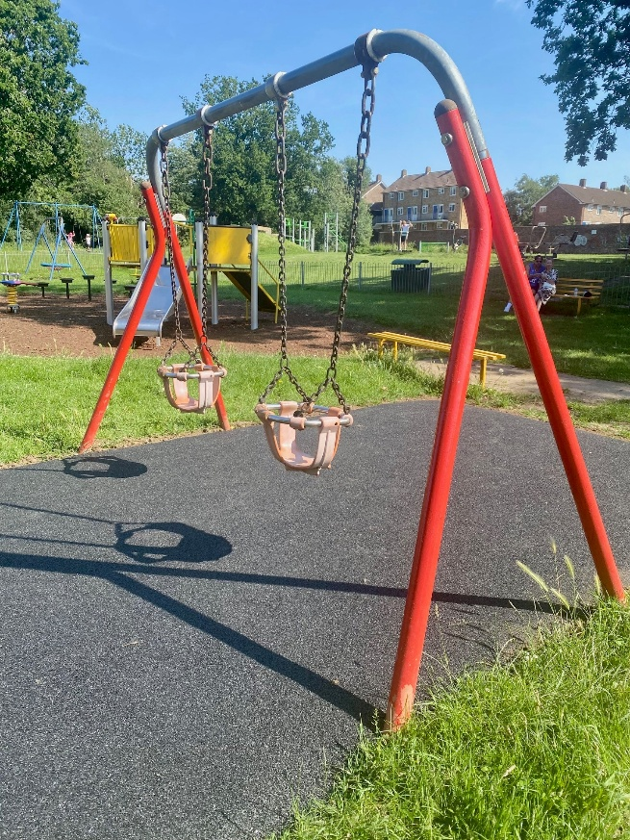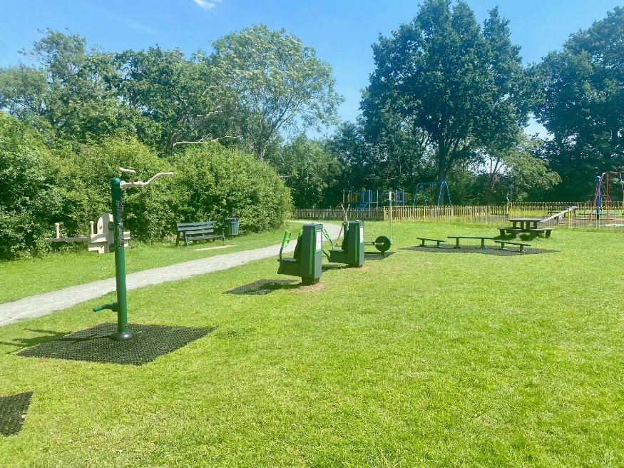

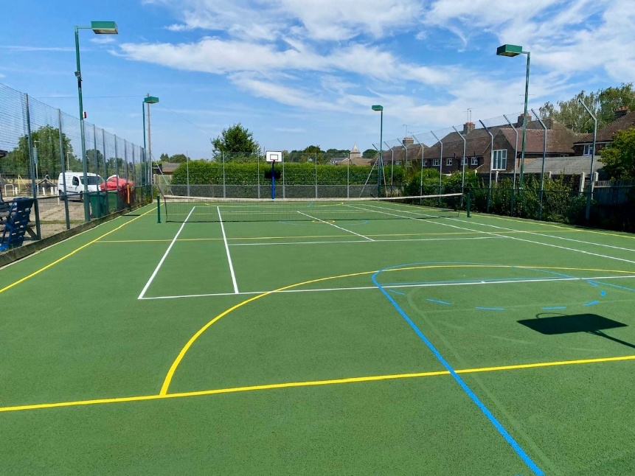

- Creating a Community Labryinth
The following email was received with regard to creating a community labyrinth;

I was interested to read in the community magazine about the opportunity for residents to put forward ideas for future community projects, and I would like to propose the creation of a community labyrinth.
A labyrinth is a simple winding pathway that leads to a central point and returns out again. Unlike a maze, there are no dead ends or puzzles to solve. Its purpose is not navigation, but to provide a space for walking, reflection, connection, and wellbeing.
Modern life often leaves many people feeling rushed, distracted, and disconnected from both nature and one another. A labyrinth would offer a free, inclusive, and accessible space where people of all ages could slow down, walk, reflect, and engage more deeply with the surrounding environment. It could be used for quiet contemplation, mindful walking, community events, school activities, wellbeing initiatives, and intergenerational projects.
My interest in labyrinths comes from both my professional and academic background. I am an accredited counsellor, a labyrinth facilitator and am currently undertaking master’s-level study exploring the relationship between wellbeing, meaning-making, movement, and connection with nature. As part of this work, I designed and built a small labyrinth and explored its use as a reflective, nature-based practice over several weeks.
This experience provided valuable insight into how structured movement and engagement with the environment can support reflection, wellbeing, and a sense of connection with place. It also highlighted that the process of creating a labyrinth can itself encourage stewardship, participation, and a deeper relationship with the natural environment.
I believe a community-designed and community-built labyrinth could offer benefits beyond the finished space itself. Local residents, schools, community groups, gardeners, and volunteers could be involved in its design, creation, and ongoing care, helping to foster a sense of ownership and belonging while creating a lasting community asset. If there is interest, I would be very happy to be involved as part of a collaborative leadership team, working alongside appropriate professionals, designers, and community partners to help shape and support the development of the project.
The labyrinth could be created in a variety of ways depending on available space and resources, from a simple grass-cut design to a more permanent installation incorporating natural materials, planting, artwork, or wildlife-friendly features. It could become a distinctive feature within the community while remaining low-cost and accessible.
I have attached two photos of local labyrinths, my own 3 circuit design in the back garden and a larger grass-cut design at Ashridge House in Hemel Hempstead.
Potential community benefits include:
• Supporting wellbeing and mental health
• Encouraging gentle physical activity
• Creating opportunities for reflection and mindfulness
• Strengthening community participation and connection
• Providing opportunities for intergenerational engagement
• Enhancing local green spaces
• Encouraging environmental awareness and stewardship
I would welcome the opportunity to discuss the idea further and explore whether it might be suitable as part of the community’s future development plans.

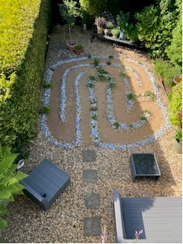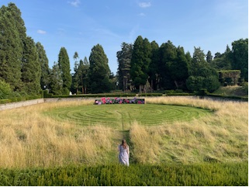

The Committee may wish to consider a suitable location for such a project and whether a small working group be created to pursue the idea.

- Repairs to Swinging Steps in Jersey Farm Adventure Playground
Repairs are due to be undertaken following independent play inspection recommendation. This work will be carried out at the earliest opportunity and includes the following;
- Replace worn top lugs
- Cut off and install eyebolts
- Renew vertical chains to triangular foot bar
- Renew non-compliant top bolt with compliant fixings.
- On the lower chain assembly, replace lower lugs with eyebolts, renew lower chain and each connecting frame bracket.

The cost for the above works is £1,000, and the Committee is asked to ratify this. It is therefore;

Recommended
To ratify the spend of £1,000 on repairs to the swinging steps.

- Postponement of Transfer of the Wheat Close Playground
It has been informally agreed by Councillors not to continue with this acquisition at this time because of budgetary restraints.

- BoxUp
Cllr Lambert has provided a summary account of his proposal, attached. Following discussion from the Committee, it is then:

RECOMMENDED
To explore full costings of a 6 locker station for one location in the parish as a pilot. Sherwood Park, JFAP or Harness Way Open Space would be the prime candidates.

- Shade cover for playgrounds
To discuss the potential need to invest in sail canopies to enable facilities to be used more safely in full summer sun. Cllr Lambert has recommended members look at the following websites to see examples;
https://auracanopies.com/
https://www.fawns.co.uk/products/canopies
https://sovereignplayequipment.co.uk/playground-shades-shelters/shade-sails/

It is;

Recommended
To decide whether to research costings and viability of installing a sail canopy for shade in one of the parish playgrounds.

- Request from resident to install an access gate onto the rear of their property onto Spencer Meadow Car-park
A request was made to the office by a resident of Hopkins Crescent asking the Parish Council to consider granting permission for an access gate to be installed to the rear of their property. To install the gate, a section of hedgerow (belonging to SPC) would need to be removed. It is worth noting, several neighbouring properties have such gates, but there is no record that can be found within the office archives detailing whether permission was granted for these.

- Wetpour surfacing under spider climber at Sherwood Park
The office was contacted by a resident in July whose grandson had taken a tumble off the spider climber and requested that the Committee consider installing wetpour surfacing underneath the apparatus (there are currently grass mats installed). An approximate quotation has been obtained, and it is estimated to cost in the region of £8000. The Committee is asked to consider whether this is a necessary addition. To note, no recommendation was made to amend this item on the Independent Safety Inspection Report, and it was rated “low risk”.

- Tennis Lines on Astro Court at Spencer Meadow
The Parish Council is asked to consider installing tennis lines on the astro court at Spencer Meadow. The request came from a tennis coach who regularly hires the tennis court, and believes that should the Committee procced, our income for the courts will increase due to the increase in demand he has for tennis lessons that could include both courts. It is worth noting that hire for tennis is unlikely to affect the football clubs, whose hire is mainly during evening hours. To paint lines on the Astro surface, the cost would be £795. The coach would be responsible for providing his own collapsible tennis net. It is therefore:

Recommended
To proceed with the installation of tennis lines on the Astro Court at Spencer Meadow.

- Cricket / Football Pitch fees
The grounds maintenance contract value is expected to increase IRO 3.5% in 2026/27. The table below shows the current rates for the parish sports pitches:

Use | Current | Proposed | Increase (3.5%)
 | £ | £ | £
Football Pitch | 1,105 annually | 1,144 | 39
Cricket Pitch | 2,590 annually | 2,681 | 91
Tennis/Netball Court | 6/12 per hour | 6/12 | 0
Astro Court | 6/15 per hour | 6/15 | 0

(the 6/12 6/15 represents the cost of hire to individuals and to teams respectively)

Floodlight tokens are currently £10 per hour.

RECOMMENDED:
To increase pitch fees by 3.5% and leave the hire of the MUGA’s and flood lights the same. Tennis/netball and Astro court hire is recommended not to increase within the current economic environment, and given their use is currently yielding high income levels.

- Committee Walkabout
Reflect on Committee walkabouts.

- Matters of Note
- Ten more key fobs have been purchased for the MUGA’s at Spencer Meadow
- Two new junior teams have made long-term bookings on the astroturf at Spencer Meadow
- The newly installed resistance machines at Harness Way have had some teething issues and Fresh Air Fitness have been on site on several occasions to rectify issues.
- Following on from the independent play inspections, repairs have been carried out on the skate ramp including two new Skatelite sheets, repainting and repair of the platforms and replacement of missing bolts.
- The mature Oak tree in William Bell is going to be fenced in order to allow the grass underneath to grow, reducing evaporation and increasing water retention. This is on recommendation from arboriculturists following an internal decay inspection.

- Any other Business

- Matters Arising Since the Circulation of the Agenda

- Suggestions for Future Meetings

Date of next meeting – 7:30pm Wednesday 2nd December 2026 at Marshalswick Community Centre

