Sandridge Parish Council

Simon Thwaites Marshalswick Community Centre,
Parish Clerk The Ridgeway, St. Albans,
Herts, AL4 9TU Tel: 01727 831871 Email: clerk@sandridge-pc.gov.uk

12th March 2026 www.sandridge-pc.gov.uk

TO: MEMBERS OF THE SPORTS AND RECREATION GROUNDS COMMITTEE

Councillors: James Lambert (Chair), Carol Chalkley, Mike White, Raihanna Ahmed, Graham Leonard, Jenny Roberts

Public members: Jez Cox, Chris Cooke

Officers: Rebecca Pannese; Project, Amenities and Community Engagement (PACE) Officer
Simon Thwaites; Parish Clerk

A meeting of the Sports and Recreation Grounds Committee is to be held on Wednesday 18th March 2026 at 7.30pm at Marshalswick Community Centre.

A G E N D A

- Apologies for Absence

- Disclosures of Interest and Dispensations
To receive declarations of interest from Members on items on the agenda and to receive
written requests for dispensations for declarable interests.

- To approve the minutes of the Sports and Recreation Grounds Committee meeting held
on the 3rd December 2025

- 2026/27 Capital Works
The budget for 2026/27 is as follows;

- £40,000 Capital works (currently unallocated)
- £5,750 General playground expenses
- £25,000 will be moved from general reserves to earmarked reserves for future capital works.

Recommendations for Capital works

Harness Way Fitness Area
Following discussion at the previous Committee meeting regarding installations that appeal to older children / teens, a quote has been obtained to install six individual gym items (as per accompanied sheet). Harness Way was selected as a possible location, due to the new path providing accessibility in all weathers and the size of the open space being spacious enough to accommodate the apparatus.

- The supply, install and delivery 6 pieces (including 3 pieces with progressive resistance for targeted training)
- Grass matting around each piece to protect key wear spots and as an added safety measure
- Compliance sign in order to ensure that the site is compliant with the existing outdoor gym standard
- Existing customer discount against the equipment cost

The cost of purchase and installation of the equipment is £14,978
It is therefore:

RECOMMENDED
To proceed with the purchase and installation of six individual pieces of fitness equipment at Harness Way Open Space.

Spencer Meadow – Court 1 line repainting
A quote has been obtained to clean, treat and repaint the lines of Court 1 to the following specification;
- Removal of all loose particles from surface.
- High pressure wash removing excess dirt, moss and stones to help improve the drainage and safety.
- Application of moss treatment.
- Spray two coats of textured acrylic tennis court colouring in dark green.
- Mark out and paint one set of white tennis lines, yellow netball and basketball in light blue lines with textured line paint

Total cost - £2,645.00
It is therefore:

RECOMMENDED
To proceed with the line painting and maintenance works on Court 1 at Spencer Meadow.

Replacement bollards for Sherwood
A quote has been obtained to replace the 8 bollards outside Sherwood Open Space. The current wooden ones are rotting and pose a risk of incursion should they fail.

The cost to replace the bollards with a sustainable alternative, including installation and removal of existing posts is IRO £1100
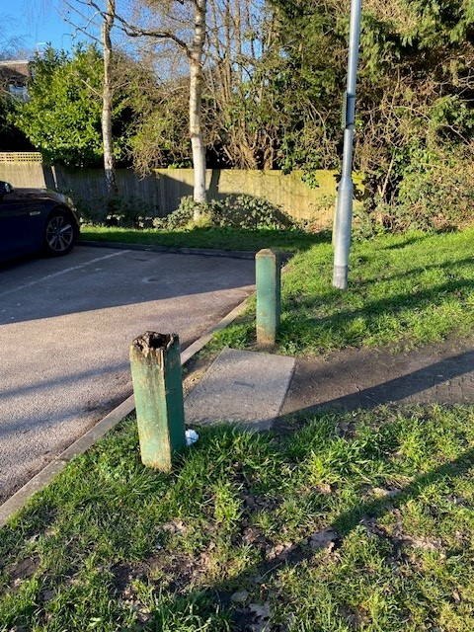

It is therefore:

RECOMMENDED
To proceed with the replacement bollards at Sherwood Park Open Space

Surfacing under toddler swings in Sherwood Playground
The grass mat surface under both sets of toddler swings has eroded and during recent wet weather was muddy and un-inviting. A quote has been obtained to install wetpour surfacing under both sets of swings, allowing all year usage and improving the general appearance of the playground. See below photos of the current surface;

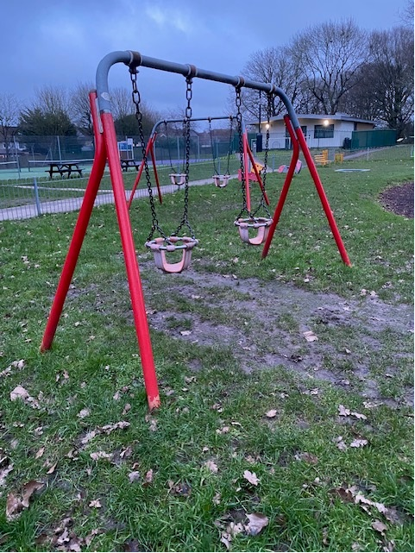

The total cost for both swing sets including preparation and installation is £6592.00
It is therefore:

RECOMMENDED
To proceed with the installation of wetpour under the two sets of toddler swings in Sherwood playground.

Improving the goal mouths at William Bell and Harness Way Open Space
The goal mouths at these two playgrounds suffer from erosion (see photo below). Research has been carried out into finding a solution which is outlined below;

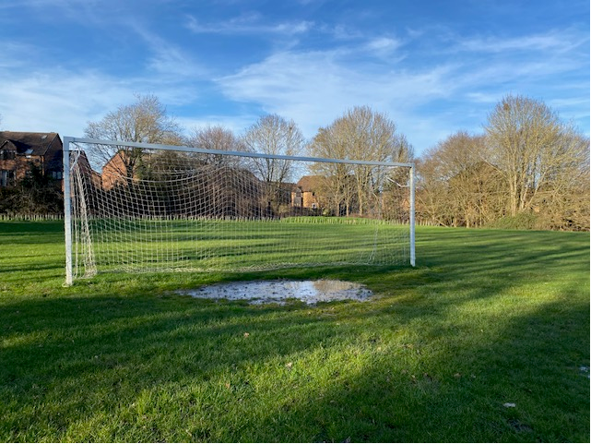

- Install soil (Approx. 2.5 tons per goal), compact down and lay grass seed
- Lay stabilizing mesh 7.5m wide x 5m deep to support grass mats
- Install rubber grass mats 7.5m x 5m to prevent ground eroding.

A quote has been obtained for £5,060.00 to do the above for the four goals in William Bell Open Space and Harness Way Open Space (£1,265 per goal).
It is therefore:

RECOMMENDED
To proceed with the works to improve the goal mouths at Willaim Bell Open Space and Harness Way Open Space.

- Replacement notices on playground gates
With the UK becoming increasingly litigious, and to mitigate the risk any legal claims, members may wish to consider adding disclaimer signs at the entrance to all of the facilities we operate. Suggested wording is as follows:

Sandridge Parish Council – Play Area Notice

This play area is provided and maintained by Sandridge Parish Council for the enjoyment of the community.

• Children should be supervised by a responsible adult at all times.
• Equipment should be used only for its intended purpose.
• Users do so at their own risk.
• The Parish Council accepts no liability for loss, damage, or injury sustained through misuse of the equipment or failure to follow this guidance.
• Please report any damage, defects, or concerns to Sandridge Parish Council.

Thank you for helping us keep this play area safe and enjoyable for everyone.

The approximate cost to purchase one sign at each of the seven playgrounds is £620
It is therefore:

RECOMMENDED
To proceed with the purchase and installation of the above signs at all seven of the parish playgrounds.

- Trampolines in Harness Way
The trampolines have suffered from flooding over the extensive wet winter season, with the regular John O’Conner operative periodically pumping out water from the steel base. Enquiries have been made with a contractor regarding drainage solutions to prevent (or reduce) future flooding and the suggested works are to install land drainage to the nearby pond by the following method;
- Excavate trenches approx. 300mm wide x 500mm deep (approx. 25 metres in length)
- Line trench with ground membrane
- Install 100mm land drainage pipe and cover with pea shingle approx. 300mm deep
- Cover shingle with permeable membrane
- Back fill with soil and seed.

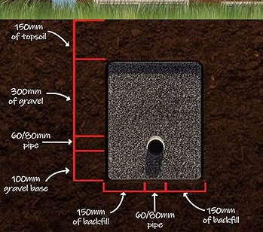

The total cost for the above works is £2,750.00
It is therefore:

RECOMMENDED
To proceed with the works to improve the drainage of the inground trampolines in the Harness Way Playground.

- Committee Walkabout
Members are requested to arrange a date/dates for a committee walkabout.

- Matters of Note
- The new swing set in the William Bell playground has been painted, along with the existing junior swing set and the roundabout.
- Usage of the MUGA’s in Spencer Meadow has continued to be high, generating good income levels each month.
- Transfer of the Wheat Close Playground has been delayed and will now likely take place over the summer months.

- Any other Business

- Matters Arising Since the Circulation of the Agenda

- Suggestions for Future Meetings

Date of next meeting – 7:30pm Wednesday 17th June 2026 at Marshalswick Community Centre

